GIT Working 13-Feb-2017

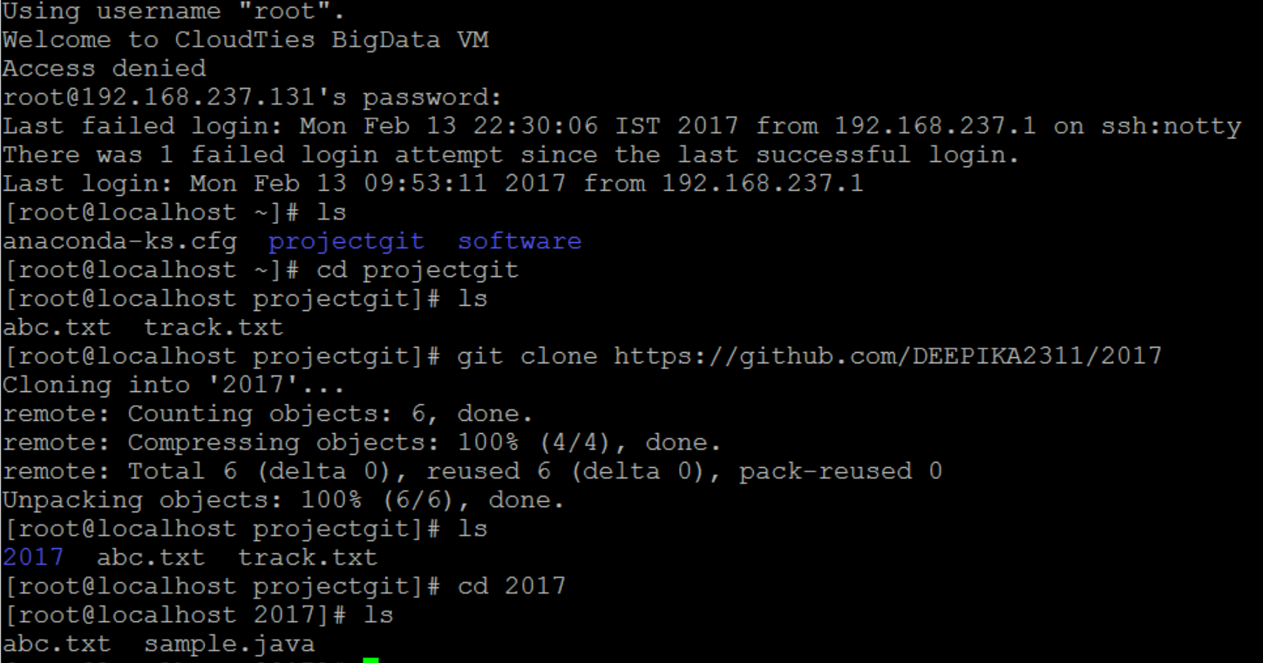

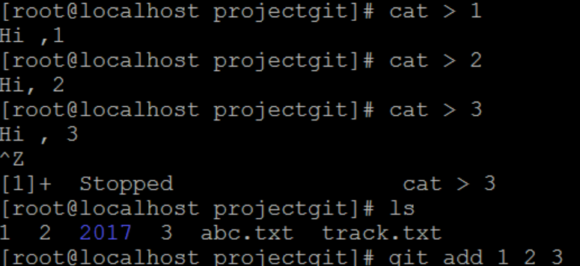

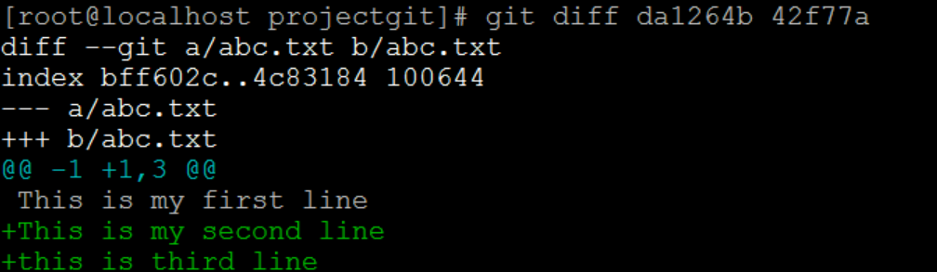

Log –pretty=oneline gives commit ids and its msgs

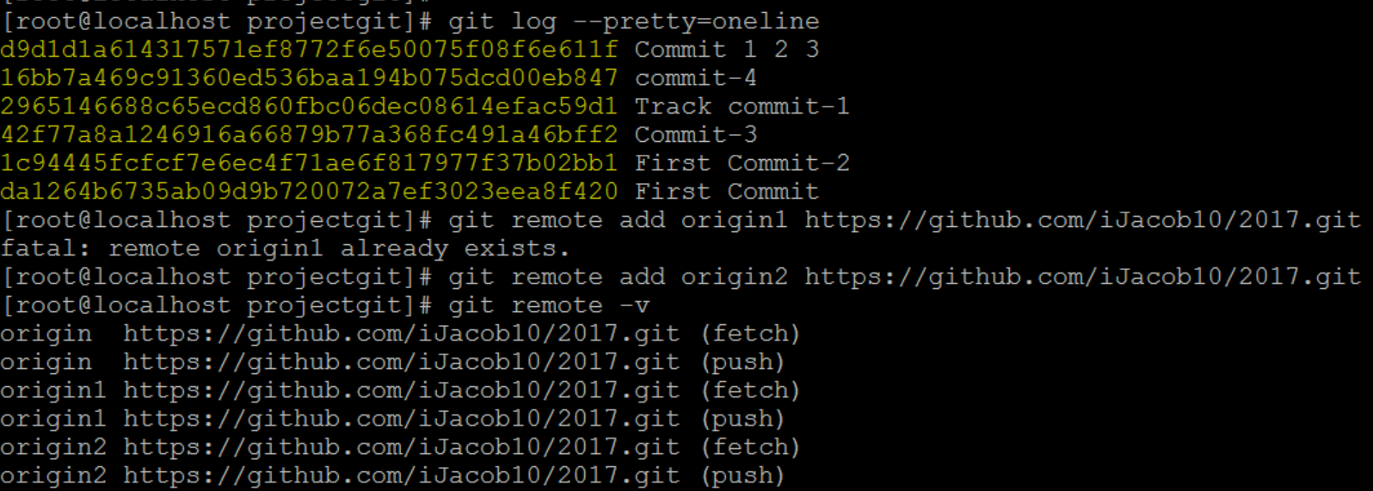

GIT – Tags->> Annotated and LightWeight tag

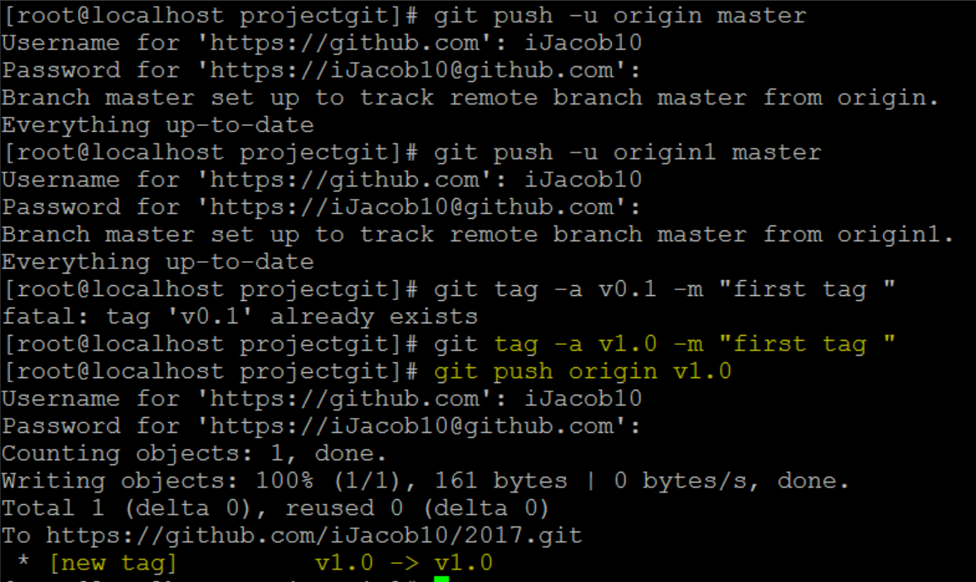

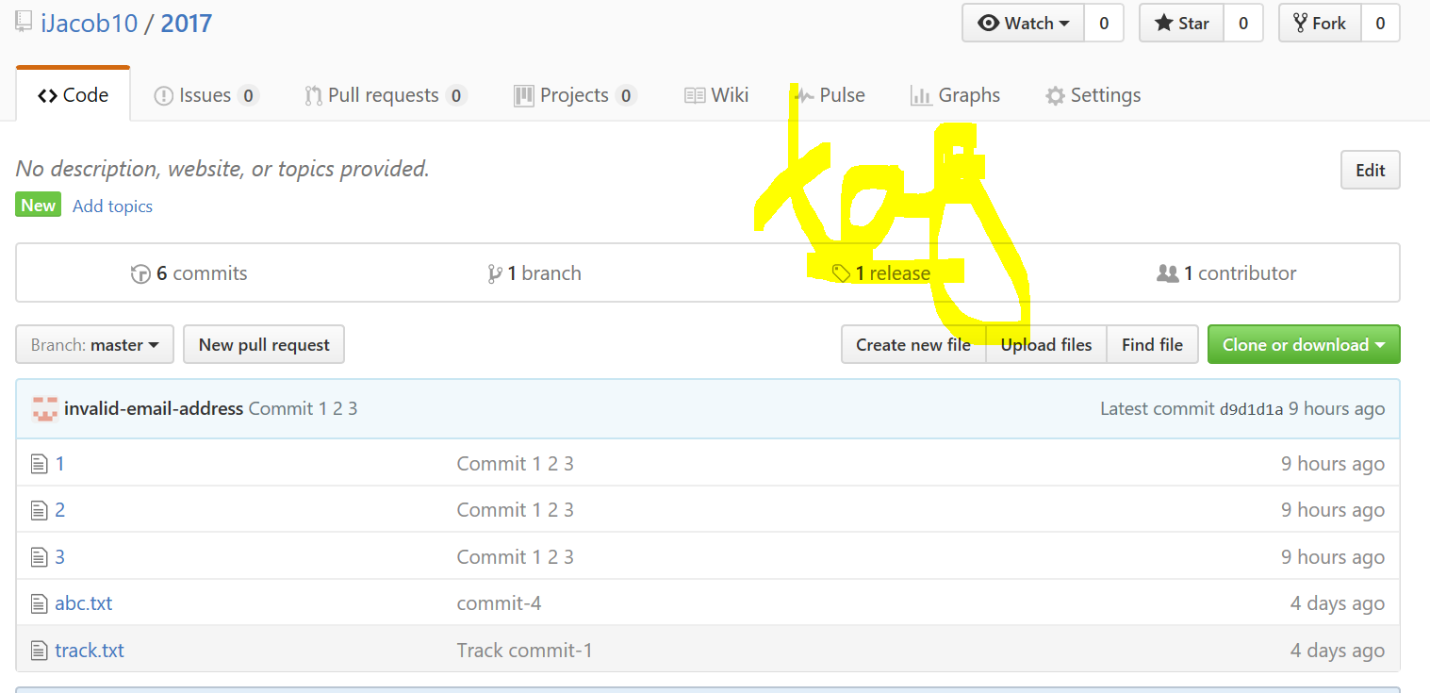

Tag ->> new release of certain versions

New BRANCH ->>>>>development1

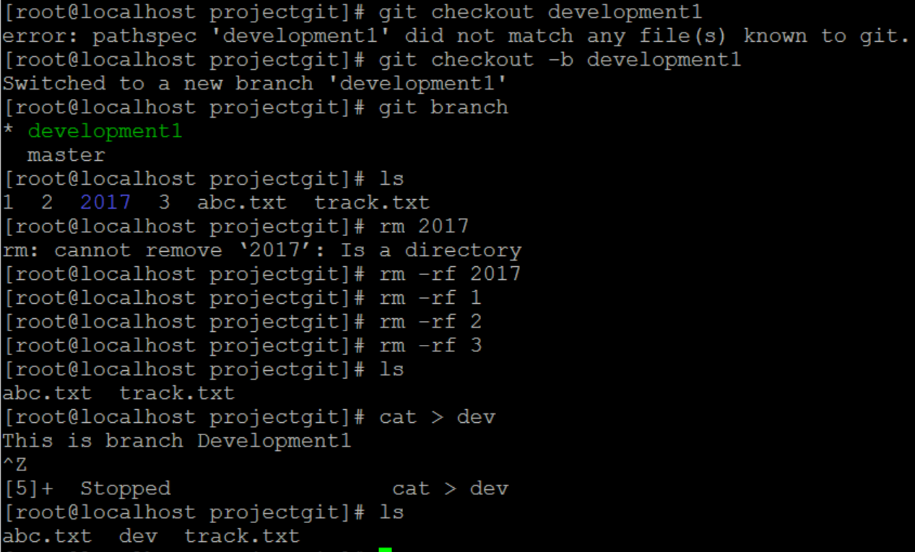

BRANCH switches to new module

CHECKOUT is used to switch to new branch …its similar to Link (ln command) aft we update the branch we need to PUSH to global Repository

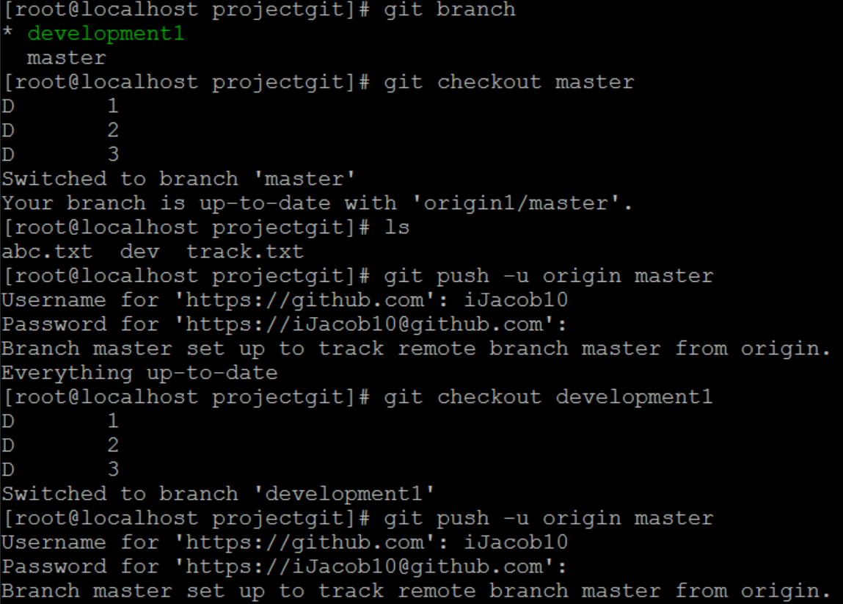

STEPS: To update to new branch “development1”

[root@localhost projectgit]# ls

abc.txt dev track.txt

[root@localhost projectgit]# git add dev add dev file to local repo

[root@localhost projectgit]# git commit -am "development1 commit 2" commit dev file to local repo

[root@localhost projectgit]# git push -u origin development1 now PUSH to Global repo

Username for 'https://github.com': iJacob10

Password for 'https://iJacob10@github.com':

Counting objects: 3, done.

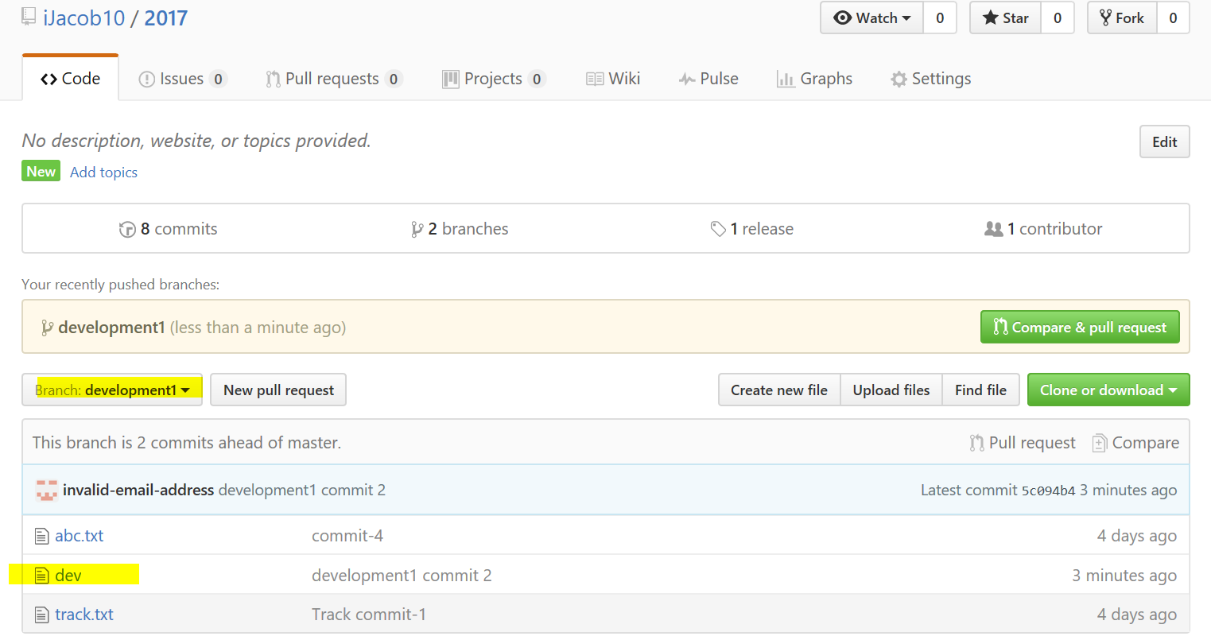

To MERGE the files from another BRANCH i.e from development1 to master

But each and every time we create a file …we need to ADD ,COMMIT and PUSH -> to view in the global repository

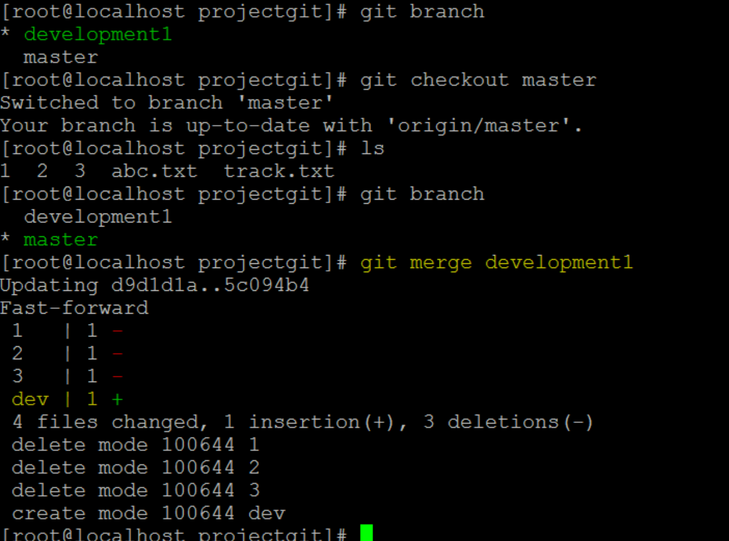

ASK???

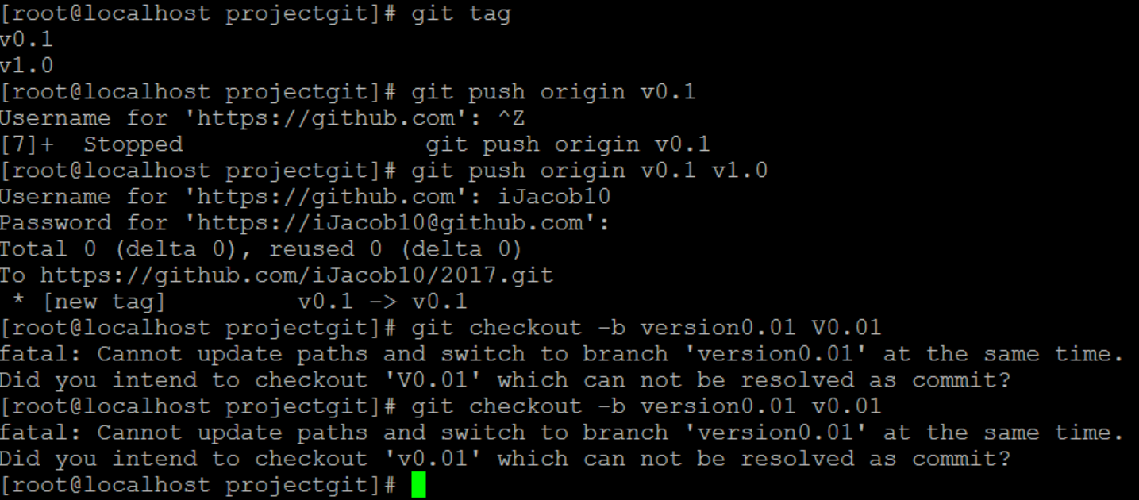

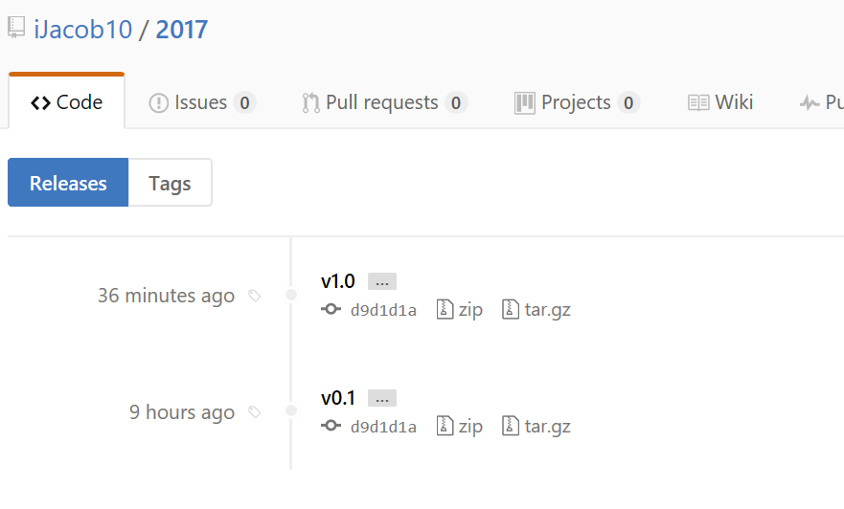

FETCH and PULL

|  |  |
| --- | --- |
| **Fetch** | **Pull** |
| Gives details | Fetch+merge data |
| Safe | Unsafe/Dangerous |
| Wont overwrite | Overwrites(so better PULL to new branch) |
| Git fetch origin master | Git pull origin master |

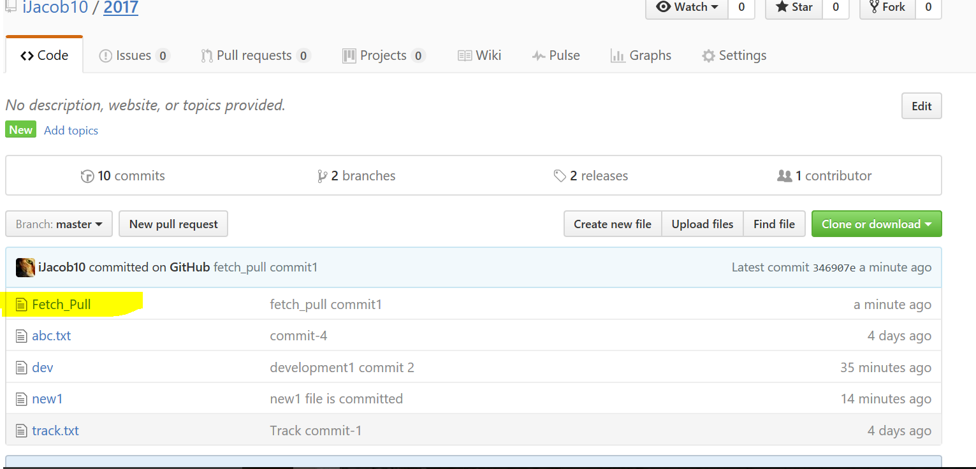

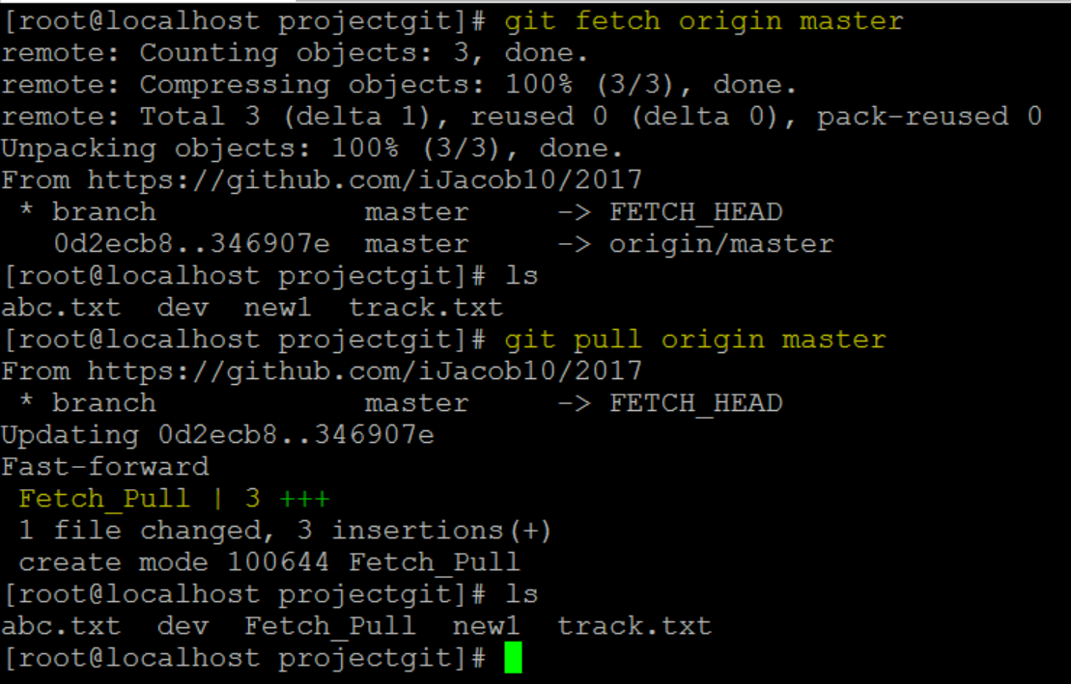

|  |
| --- |
|  |
|  | Download jdk file from this url |
|  |  |
|  | http://www.oracle.com/technetwork/java/javase/downloads/jdk8-downloads-2133151.html |
|  |  |
|  |  |
|  | ***INSTALLING INTELLIJ*** |
|  | ---------------------- |
|  |  |
|  | Download Intellij for Linux from the jetbrains website. You can download this with your browser: |
|  |  |
|  | <https://www.jetbrains.com/idea/download/download-thanks.html?platform=linux&code=IIC> |
|  |  |
|  |  |
|  | copy tar file to /opt/directory |
|  |  |
|  | chown -R root:root /opt/rea* |
|  |  |
|  | ln -s /opt/idea-IC-163.10154.41/bin/idea.sh /usr/local/bin/idea.sh |
|  |  |
|  | idea.sh |
|  |  |
|  |  |
|  | Note: Version Intellij 15 shows error message: “IBus prior to 1.5.11 may cause input problems. See IDEA-78860 for details.” It doesn’t seem to cause me any problems. You can click the link: “Do not show again.” |
|  |  |
|  |  |
|  |  |

Using username "root".

Welcome to CloudTies BigData VM

Access denied

root@192.168.237.131's password:

Last failed login: Tue Feb 14 12:49:52 IST 2017 from 192.168.237.1 on ssh:notty

There was 1 failed login attempt since the last successful login.

Last login: Tue Feb 14 12:31:26 2017

[root@localhost ~]# cd opy

-bash: cd: opy: No such file or directory

[root@localhost ~]# cd opt

-bash: cd: opt: No such file or directory

[root@localhost ~]# cd /opt

[root@localhost opt]# cd software

[root@localhost software]# mkdir java

[root@localhost software]# cd java

[root@localhost java]# wget http://download.oracle.com/otn-pub/java/jdk/8u121-b13/e9e7ea248e2c4826b92b3f075a80e441/jdk-8u121-linux-x64.rpm

--2017-02-14 12:50:44-- http://download.oracle.com/otn-pub/java/jdk/8u121-b13/e9e7ea248e2c4826b92b3f075a80e441/jdk-8u121-linux-x64.rpm

Resolving download.oracle.com (download.oracle.com)... 23.78.220.67, 23.78.220.34

Connecting to download.oracle.com (download.oracle.com)|23.78.220.67|:80... connected.

HTTP request sent, awaiting response... 200 OK

Length: 11744 (11K) [text/html]

Saving to: ‘jdk-8u121-linux-x64.rpm’

100%[=================================================>] 11,744 --.-K/s in 0.03s

2017-02-14 12:50:47 (330 KB/s) - ‘jdk-8u121-linux-x64.rpm’ saved [11744/11744]

[root@localhost java]# du -h http://download.oracle.com/otn-pub/java/jdk/8u121-b13/e9e7ea248e2c4826b92b3f075a80e441/jdk-8u121-linux-x64.rpm

du: cannot access ‘http://download.oracle.com/otn-pub/java/jdk/8u121-b13/e9e7ea248e2c4826b92b3f075a80e441/jdk-8u121-linux-x64.rpm’: No such file or directory

[root@localhost java]# ^C

[root@localhost java]# ls

jdk-8u121-linux-x64.rpm

[root@localhost java]# du -h jdk-8u121-linux-x64.rpm

12K jdk-8u121-linux-x64.rpm

[root@localhost java]# cd ..

[root@localhost software]# ls

git-2.12.0-rc0 git-2.12.tar.gz hadoop java JAVA jdk-8u121-linux-x64.rpm R

[root@localhost software]# cd ..

[root@localhost opt]# cd software/

[root@localhost software]# ls

git-2.12.0-rc0 git-2.12.tar.gz hadoop java JAVA jdk-8u121-linux-x64.rpm R

[root@localhost software]# mkdir IntelliJ

[root@localhost software]# cd IntelliJ/

[root@localhost IntelliJ]# wget https://download.jetbrains.com/idea/ideaIC-2016.3.4.tar.gz

--2017-02-14 13:16:30-- https://download.jetbrains.com/idea/ideaIC-2016.3.4.tar.gz

Resolving download.jetbrains.com (download.jetbrains.com)... 54.225.64.222

Connecting to download.jetbrains.com (download.jetbrains.com)|54.225.64.222|:443... connected.

HTTP request sent, awaiting response... 302 Moved Temporarily

Location: https://download-cf.jetbrains.com/idea/ideaIC-2016.3.4.tar.gz [following]

--2017-02-14 13:16:33-- https://download-cf.jetbrains.com/idea/ideaIC-2016.3.4.tar.gz

Resolving download-cf.jetbrains.com (download-cf.jetbrains.com)... 52.85.202.95, 52.85.202.138, 52.85.202.185, ...

Connecting to download-cf.jetbrains.com (download-cf.jetbrains.com)|52.85.202.95|:443... connected.

HTTP request sent, awaiting response... 200 OK

Length: 410616087 (392M) [binary/octet-stream]

Saving to: ‘ideaIC-2016.3.4.tar.gz’

100%[=================================================>] 410,616,087 4.51MB/s in 1m 46s

2017-02-14 13:18:20 (3.71 MB/s) - ‘ideaIC-2016.3.4.tar.gz’ saved [410616087/410616087]

[root@localhost IntelliJ]# ls

ideaIC-2016.3.4.tar.gz

[root@localhost IntelliJ]# tar -xzf ideaIC-2016.3.4.tar.gz

[root@localhost IntelliJ]# ls

idea-IC-163.12024.16 ideaIC-2016.3.4.tar.gz

[root@localhost IntelliJ]# rm ideaIC-2016.3.4.tar.gz

rm: remove regular file ‘ideaIC-2016.3.4.tar.gz’? yes

[root@localhost IntelliJ]# ls

idea-IC-163.12024.16

[root@localhost IntelliJ]# cd idea-IC-163.12024.16/

[root@localhost idea-IC-163.12024.16]# ls

bin Install-Linux-tar.txt lib LICENSE.txt plugins

build.txt jre license NOTICE.txt redist

[root@localhost idea-IC-163.12024.16]# cd ..

[root@localhost IntelliJ]# ls

idea-IC-163.12024.16

15 FEB-----***NAGIOS INSTALLATION***

|  |
| --- |
|  |
| yum install php |
|  |  |
|  | yum install httpd* |
|  |  |
|  | This section will cover how to install Nagios 4 on your monitoring server. You only need to complete this section once. |
|  |  |
|  | Install Build Dependencies |
|  | -------------------------- |
|  |  |
|  | yum install gcc glibc glibc-common gd gd-devel make net-snmp openssl-devel xinetd unzip –y –skip-broken |
|  |  |
|  | Create Nagios User and Group |
|  | ---------------------------- |
|  |  |
|  | useradd Nagios |
|  | groupadd nagcmd |
|  | usermod -a -G nagcmd Nagios |
|  |  |
|  |  |
|  | Install Nagios Core /opt/software/Nagios |
|  | ------------------- |
|  |  |
|  | wget <https://assets.nagios.com/downloads/nagioscore/releases/nagios-4.1.1.tar.gz> |
|  |  |
|  | Extract the Nagios archive with this command: |
|  |  |
|  | tar xzf nagios-4.1.1.tar.gz |
|  |  |
|  | cd nagios-4.1.1. |
|  |  |
|  |  |
|  | Before building Nagios, we must configure it with this command: |
|  | -------------------------------------------------------- |
|  |  |
|  | ./configure --with-command-group=nagcmd |
|  |  |
|  | Now compile Nagios with this command: |
|  |  |
|  | make all |
|  |  |
|  | Now we can run these make commands to install Nagios, init scripts, and sample configuration files: |
|  | -------------------------------------------------------------------------------------------- |
|  |  |
|  | make install |
|  |  |
|  | make install-commandmode |
|  |  |
|  | make install-init |
|  |  |
|  | make install-config |
|  |  |
|  | make install-webconf |
|  | /usr/bin/install -c -m 644 sample-config/httpd.conf /etc/httpd/conf.d/nagios.conf  *** Nagios/Apache conf file installed *** FOR INTERFACE |
|  | In order to issue external commands via the web interface to Nagios, we must add the web server user, apache, to the nagcmd group: |
|  | ------------------------------------------------------------------------------------------ |
|  |  |
|  | usermod -G nagcmd apache |
|  |  |
|  | id apache  root@localhost nagios-4.1.1]# id apache  uid=48(apache) gid=48(apache) groups=48(apache),1003(nagcmd) |
|  | Install Nagios Plugins(add on scripts) |
|  | ======================= |
|  |  |
|  | latest version is Nagios Plugins 2.1.1. Download it to your home directory |
|  |  |
|  | # wget http://nagios-plugins.org/download/nagios-plugins-2.1.1.tar.gz |
|  |  |
|  | Extract Nagios Plugins archive with this command: |
|  | [root@localhost nagios-4.1.1]# mv nagios-plugins-2.1.1.tar.gz /opt/software/Nagios/  <http://nagios-plugins.org/download/>  download 2.2 tar file ….and move it to Nagios i.e using Winscp |
|  | tar -zxf nagios-plugins-2.2.0.tar.gz |
|  |  |
|  | cd nagios-plugins-2.2.0/ |
|  |  |
|  | Before building Nagios Plugins, we must configure it. Use this command: |
|  | ----------------------------------------------------------------------- |
|  |  |
|  | ./configure --with-nagios-user=nagios --with-nagios-group=nagios --with-openssl |
|  |  |
|  | Now compile Nagios Plugins with this command: |
|  |  |
|  | make |
|  |  |
|  | Then install it with this command: |
|  |  |
|  | make install |
|  |  |
|  |  |
|  | Install NRPE /opt/software.nagios |
|  | ============= |
|  |  |
|  | latest release is 2.15. Download it to your home directory |
|  | (https://sourceforge.net/projects/nagios/files/nrpe-2.x/nrpe-2.15/nrpe-2.15.tar.gz/download) |
|  | wget http://downloads.sourceforge.net/project/nagios/nrpe-2.x/nrpe-2.15/nrpe-2.15.tar.gz |
|  |  |
|  |  |
|  | tar -zxf nrpe-2.15.tar.gz |
|  |  |
|  | cd nrpe-2.15. |
|  |  |
|  | Configure NRPE with these commands: |
|  | ----------------------------------- |
|  |  |
|  | ./configure --enable-command-args --with-nagios-user=nagios --with-nagios-group=nagios --with-ssl=/usr/bin/openssl --with-ssl-lib=/usr/lib/x86_64-linux-gnu |
|  |  |
|  | Now build and install NRPE and its xinetd startup script with these commands: |
|  | ------------------------------------------------------------------------------- |
|  |  |
|  | make all |
|  |  |
|  | make install |
|  |  |
|  | make install-xinetd |
|  |  |
|  | make install-daemon-config |
|  |  |
|  |  |
|  | Open the xinetd startup script in an editor: |
|  | -------------------------------------------- |
|  |  |
|  | vi /etc/xinetd.d/nrpe |
|  |  |
|  | Modify the only_from line by adding the private IP address of the your Nagios server to the end (substitute in the actual IP address of your server) |
|  |  |
|  | only_from = 127.0.0.1 16.184.47.43 |
|  |  |
|  | Save and exit. Only the Nagios server will be allowed to communicate with NRPE. |
|  |  |
|  | Restart the xinetd service to start NRPE: |
|  | ------------------------------------------ |
|  | cfg_dir=/usr/local/nagios/etc/servers |
|  | Service xinetd start  Chkconfig xinetd on  Service nagios start  Chkconfig nagios on  Service httpd  service xinetd restart  [root@localhost ~]# tail -n 100 /var/log/httpd/error_log |
|  |  |
|  |  |
|  |  |
|  | Now that Nagios 4 is installed, we need to configure it. |
|  | ========================================================= |
|  |  |
|  | Configure Nagios |
|  | ================= |
|  |  |
|  |  |
|  | Open the main Nagios configuration file |
|  |  |
|  | vi /usr/local/nagios/etc/nagios.cfg |
|  |  |
|  | Now find an uncomment this line by deleting the #: |
|  |  |
|  | cfg_dir=/usr/local/nagios/etc/servers |
|  |  |
|  | Save and exit. |
|  |  |
|  |  |
|  | Now create the directory that will store the configuration file for each server that you will monitor |
|  |  |
|  | mkdir /usr/local/nagios/etc/servers |
|  |  |
|  |  |
|  | Configure Nagios Contacts |
|  | ------------------------- |
|  |  |
|  | Open the Nagios contacts configuration |
|  |  |
|  | vi /usr/local/nagios/etc/objects/contacts.cfg |
|  |  |
|  | Find the email directive, and replace its value (the highlighted part) with your own email address: |
|  |  |
|  | save and exit; |
|  |  |
|  |  |
|  | Configure check_nrpe Command |
|  | ---------------------------- |
|  | Let's add a new command to our Nagios configuration: |
|  |  |
|  | vi /usr/local/nagios/etc/objects/commands.cfg |
|  |  |
|  | Add the following to the end of the file: |
|  |  |
|  | define command{ |
|  | command_name check_nrpe |
|  | command_line $USER1$/check_nrpe -H $HOSTADDRESS$ -c $ARG1$ |
|  | } |
|  |  |
|  |  |
|  | Save and exit. This allows you to use the check_nrpe command in your Nagios service definitions. |
|  |  |
|  |  |
|  | Configure Apache |
|  | ---------------- |
|  |  |
|  | Use htpasswd to create an admin user, called "nagiosadmin", that can access the Nagios web interface: |
|  |  |
|  |  |
|  | htpasswd -c /usr/local/nagios/etc/htpasswd.users nagiosadmin |
|  |  |
|  | Enter a password at the prompt. Remember this login, as you will need it to access the Nagios web interface. |
|  |  |
|  |  |
|  | Nagios is ready to be started. Let's do that, and restart Apache: |
|  | ------------------------------------------------------------------ |
|  |  |
|  | service nagios start |
|  |  |
|  | service httpd restart |
|  |  |
|  | To enable Nagios to start on server boot, run this command: |
|  |  |
|  | chkconfig nagios on |
|  |  |
|  |  |
|  |  |
|  |  |
|  | Accessing the Nagios Web Interface |
|  | =================================== |
|  |  |
|  |  |
|  | Open your web browser, and go to your Nagios server |
|  |  |
|  | http://16.184.47.43/nagios |
|  |  |
|  |  |
|  |  |
|  | IN CLIENT |
|  | =========== |
|  |  |
|  |  |
|  |  |
|  | Monitoring a Host with NRPE |
|  | ============================== |
|  |  |
|  | how to add a new host to Nagios, so it will be monitored |
|  |  |
|  | On a server that you want to monitor, install the EPEL repository: |
|  |  |
|  |  |
|  | yum install epel-release |
|  |  |
|  |  |
|  | Now install Nagios Plugins and NRPE |
|  | ------------------------------------ |
|  |  |
|  | yum install nrpe nagios-plugins-all |
|  |  |
|  |  |
|  | update the NRPE configuration file. |
|  | ---------------------------------- |
|  |  |
|  | vi /etc/nagios/nrpe.cfg |
|  |  |
|  |  |
|  | Find the allowed_hosts directive, and add the private IP address of your Nagios server |
|  |  |
|  | allowed_hosts=127.0.0.1,16.184.47.43 |
|  |  |
|  | Save and exit. This configures NRPE to accept requests from your Nagios server. |
|  |  |
|  | Restart NRPE to put the change into effect: |
|  | ------------------------------------------- |
|  |  |
|  | service nrpe start |
|  |  |
|  | systemctl enable nrpe.service |
|  |  |
|  |  |
|  | Once you are done installing and configuring NRPE on the hosts that you want to monitor, you will have to add these hosts to your Nagios server configuration before it will start monitoring them. |
|  |  |
|  |  |
|  |  |
|  | IN NAGIOS SERVER |
|  | =================== |
|  |  |
|  |  |
|  | Add Host to Nagios Configuration |
|  | ================================= |
|  |  |
|  | On your Nagios server, create a new configuration file for each of the remote hosts that you want to monitor in /usr/local/nagios/etc/servers/ |
|  |  |
|  |  |
|  | vim /usr/local/nagios/etc/servers/node5.cfg |
|  |  |
|  | Add the following to the file |
|  |  |
|  |  |
|  | define host { |
|  | use linux-server |
|  | host_name mca4.psdgc.cloud |
|  | alias node 5 |
|  | address 16.184.40.5 |
|  | max_check_attempts 5 |
|  | check_period 24x7 |
|  | notification_interval 30 |
|  | notification_period 24x7 |
|  | } |
|  |  |
|  | With the configuration file above, Nagios will only monitor if the host is up or down. |
|  |  |
|  |  |
|  | Add the following service which need to be monitored , |
|  |  |
|  | define service { |
|  | use generic-service |
|  | host_name mca4.psdgc.cloud |
|  | service_description PING |
|  | check_command check_ping!100.0,20%!500.0,60% |
|  | } |
|  |  |
|  |  |
|  | define service { |
|  | use generic-service |
|  | host_name mca4.psdgc.cloud |
|  | service_description SSH |
|  | check_command check_ssh |
|  | notifications_enabled 0 |
|  | } |
|  |  |
|  |  |
|  | Now save and quit |
|  |  |
|  | Check whether the configuration file is OK or not using the command |
|  |  |
|  |  |
|  | /usr/local/nagios/bin/nagios -v /usr/local/nagios/etc/nagios.cfg |
|  |  |
|  |  |
|  | Once you are done configuring Nagios to monitor all of your remote hosts, you should be set. Be sure to access your Nagios web interface, and check out the Services page to see all of your monitored hosts and services: |
|  |  |
|  |  |
|  |  |
|  |  |
|  | NOTE: |
|  | ====== |
|  |  |
|  | default samples of services will in /usr/local/nagios/etc/objects/localhost.cfg |
|  |  |
|  |  |
|  |  |
|  | Thank you........... |
|  |  |

[root@localhost NagiOS]# git clone https://github.com/shfq100/Installation.git

|  |
| --- |
|  |
|  | Download jdk file from this url |
|  |  |
|  | http://www.oracle.com/technetwork/java/javase/downloads/jdk8-downloads-2133151.html |
|  |  |
|  |  |
|  | INSTALLING INTELLIJ |
|  | ---------------------- |
|  |  |
|  | Download Intellij for Linux from the jetbrains website. You can download this with your browser: |
|  |  |
|  | https://www.jetbrains.com/idea/download/download-thanks.html?platform=linux&code=IIC |
|  |  |
|  |  |
|  | copy tar file to /opt/directory |
|  |  |
|  | chown -R root:root /opt/rea* |
|  |  |
|  | ln -s /opt/idea-IC-163.10154.41/bin/idea.sh /usr/local/bin/idea.sh |
|  |  |
|  | idea.sh |
|  |  |
|  |  |
|  | Note: Version Intellij 15 shows error message: “IBus prior to 1.5.11 may cause input problems. See IDEA-78860 for details.” It doesn’t seem |

